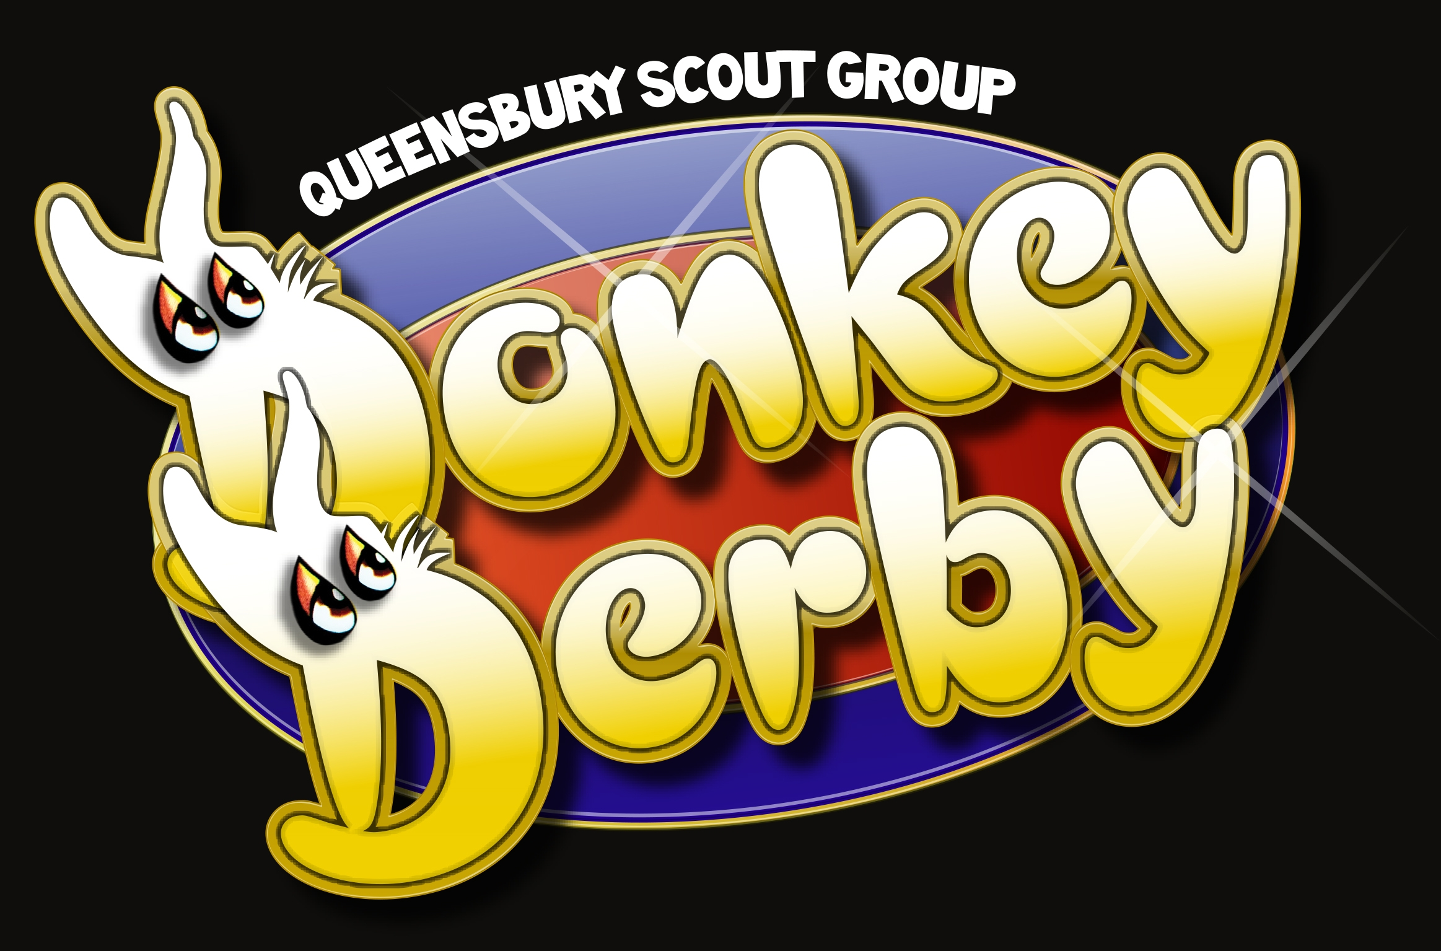
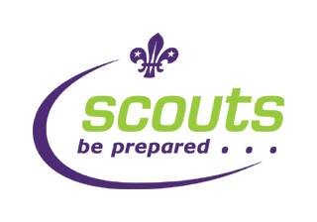
Queensbury Scout Group Donkey Derby
(Sunday 3rd July 2016 )
Race and Donkey Sponsorship

Dear Parents,
It’s time for another great Donkey Derby and we would like to give your family or business the chance to sponsor a race or donkey. We have 3 races and 12 donkeys in need of sponsorship. If you’d like to make your mark on this year’s Donkey Derby, simply fill in the details below and return the form to me at Beavers, Cubs, Scouts or Band in the week beginning 18th April. If there are more than 3 race and 12 donkey submissions I’ll draw names out of a hat. I will collect payment in the week beginning 25th April.

Thank you for your support.
Liz Fiddaman
Donkey Sponsorship (£15)

Example Listings | Fancy Do Hair Express  By Lydia 123 Any Street, Queensbury  Out of Hair Express 01234 567890  0r  In the Lead The Smith Family  By A Head  Out of Breath Now
Your Listing | Donkey name:  by:  out of: | Sponsor  details:

Race Sponsorship (£40)

Example Listings | The Hair Do Hurdles  Sponsored By Hair Express, 123 Any Street, Queensbury, 01234 567890  or  The Stephenson Steeplechase  Sponsored by the Stephenson Family
Your Listing

Contact Name: Contact number:
Section: Beavers / Cubs / Scouts / Band

18th Bradford South (Queensbury) Scout Group
Registered Charity Number: 525042

www.queensburyscouts.org.uk
www.facebook.com/queensburyscouts

Liz Fiddaman 07775 681619
liz@queensburyscouts.org.uk

